**The Excel Sheet with Scripts and Formulas**

Overview:

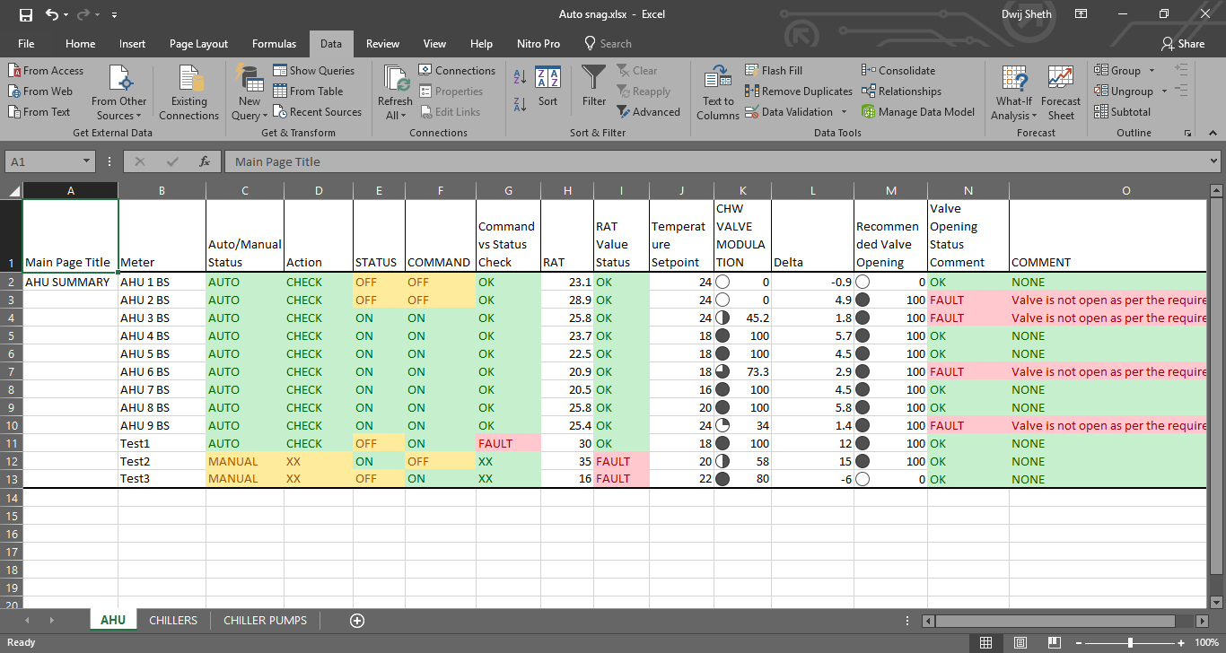

Fig- A typical Overview of the AHU Snaglist Screen

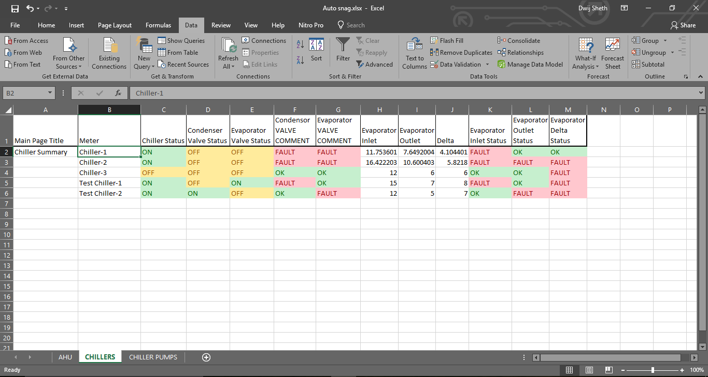

Fig-A typical Overview of the Chiller Snaglist

**The AHU Snaglist**

**Sheet Parameters:**

(The values in Yellow are provided by the user from the site during PM

The values in cyan are computed automatically based upon the entry of the Yellow marked parameters)

* **Main Page Title:** The Main page title depicts the page which is being referred with regard to the set which is being evaluated on the site
* **Meter:** This Depicts the meter or the datapoint which is being referred to with respect to the analysis.
* **Auto/Manual Status:** The Auto manual status depicts whether the user is running the Air handling unit is the automatic mode or the manual operation mode where the operator fixes up the values and the governing parameters manually.
* **Action:** Based upon the auto/manual status the Action value is computed automatically which tell whether we are running the scripts further or not as If the Auto manual status is set to manual there is no need to check the parameters.
* **Status:** The Status depicts the run status of the AHU that whether the AHU is running or not actually (Feedback Datapoint).
* **Command:** The command is the instruction passed to the AHU which indicates whether the Ahu has to run or not at any given point of time. The command is set by the controller in case of AUTO and manually by the BMS operator in case of Manual operation mode.
* **Status vs Command Test:** The status vs command check is done to check if the AHU is performing as per the given commands or not. This Parameter is Automatically calculated by the status and the command values.
* **RAT:** The Return air temperature is the temperature of the air at the end of the ahu where the AHU returns the processed air.
* **RAT Value Status:** The RAT Value Status is a dynamic status indicator which indicates errors in the return air temperatures of the AHU either due to machine failure or user errors based on the AHU run status and the actual return air temperature from the AHU via a temperature sensor.
* **Temperature Setpoint:** The Temperature setpoint which the user wants a particular AHU to return in a section at the Return point.
* **CHW Valve Modulation:** The CHW valve modulation indicates the amount of opening of the valve which allows the inlet of water from the source into the chiller.
* **Delta:** Delta is simply the temperature difference between the Return air temperature and the temperature setpoint. By using delta we get an idea of how much more colling is required etc. A positive delta means the we still need to provide more cooling, zero means that the Return air temperature has met the temperature setpoint and a negative delta means that we have dropped the return air temperature beyond the setpoint i.e. the room is over cooled now where the corresponding AHU is installed.
* **Recommended Valve opening:** It is the recommended amount of valve opening that must be provided at the inlet point for water at the chiller which is computed based on the delta that we need to reach the temperature setpoint.
* **Valve status Comment:** The Valve status comment is the comparison output of the actual CHW valve opening and the recommended valve opening and based upon that we raise the OK status or the fault status.
* **Comment:** Based on the valve status comment we analyse wether the valve is open more than the requirement or less than the necessary requirement and generate a comment to indicate the same.

**Conditions to detect the faults:**

* **Action:** For predicting the action we make use of the auto/manual status in order to tell whether we are going to run the further rule checks or not on the system as a system in manual cannot be commented upon.

Check-We will be running the scripts

XX- we will not be running the scripts

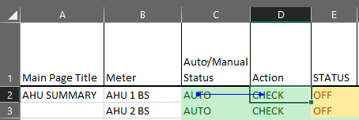

**Precedent- Dependent relation**

**Formula: =IF(EXACT(C2,"AUTO"),"CHECK","XX")**

* **Status vs Command Check:** When the system is running in the automatic mode we need to make sure that the command that we are giving to the AHU via the controller is matching the actual running status of the AHU so we run the following check on it. In case the AHU is operated in the manual mode we need not care about this and give the status as OK.

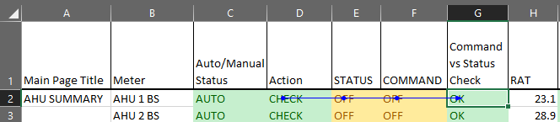

**Precedent Dependent Relation**

**Formula:** **=IF(EXACT(D2,"CHECK"),IF(EXACT(E2,F2),"OK","FAULT"),"XX")**

* **RAT Value Status:** Based upon the current Return air temperature and the AHU run status we compute the appropriate range of temperature for the RAT and compare it with the present RAT value and predict the status

If the AHU is ON, the RAT must be below the threshold limit of 26

If the AHU is ON, the RAT must be in the range of 22-30 degrees.

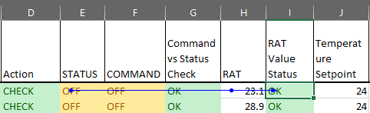

**Precedent Dependent Relation**

**Formula:** **=IF(EXACT(E2,"ON"),IF(H2<27,"OK","FAULT"),IF(AND(H2>21,H2<31),"OK","FAULT"))**

* **Delta:** It is just the temperature difference between the Return Air temperature and the temperature Setpoint

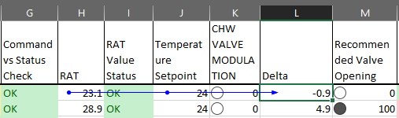

**Precedent Dependent Relation**

**Formula: =(H2-J2)**

* **Recommended Valve Opening:** The valve opening is decided based upon the delta value of the AHU based on the following Condition:
* If Delta>1 then the valve opening must be 100%
* For Delta =1 the Valve must be open at 80% and for delta=0 the valve must be open at 50% and for all the values in between the delta must be proportional to this 80-50 limits
* Similarly for Delta=-1 the valve must be open at 30% and for the values that fall in between 0 and -1 must lie between 50% and 30%
* For Delta lesser than -1 the valve opening must be set at 0%

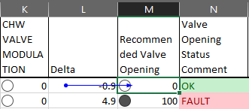

**Precedent Dependent Relation**

**Formula: =IF(L2>1,100,IF(AND(L2>0,L2=0),30*L2+50,IF(AND(L2>-1,L2=-1),20*L2+50,0)))**

* **Valve Opening Status Comment:** The valve opening status comment field compares the Recommended and the actual valve opening and tells the user that the valve I at a proper modulation or not.

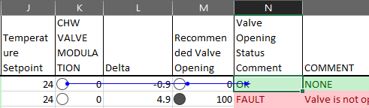

**Precedent Dependent Relation**

**Formula: =IF(M2=K2,"OK","FAULT")**

* **Comment:** Based upon the Valve status comment and the actual variation between the recommended and the actual values we generate the comment for the user.

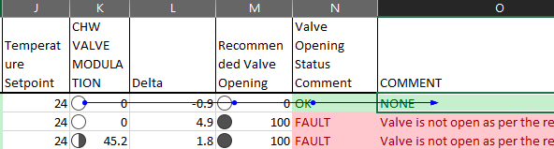

**Precedent Dependent Relation**

**Formula: =IF(EXACT(N2,"FAULT"),IF(M2<K2,"Valve is open more than requirement”, “Valve is not open as per the requirement"),"NONE")**

**Process Flow for AHU:**

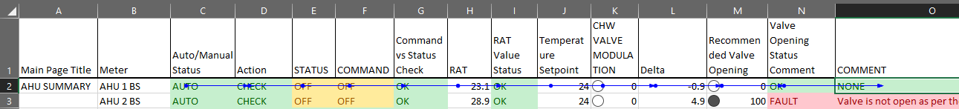

The Process Flow of a complete Process for a meter on how it is evaluated.

**The Chiller Snaglist**

**Sheet Parameters:**

(The values in Yellow are provided by the user from the site during PM

The values in cyan are computed automatically based upon the entry of the Yellow marked parameters)

* **Main Page Title:** The Main page title depicts the page which is being referred with regard to the set which is being evaluated on the site
* **Meter:** This Depicts the meter or the datapoint which is being referred to with respect to the analysis.
* **Chiller Status:** The chiller status is the run status of the chiller i.e. whether it is ON or OFF.
* **Condenser Valve Status:** The condenser valve status depicts whether the condenser water inlet valve is open or not.
* **Evaporator Valve Status:** The Evaporator valve status depicts whether the evaporator water inlet valve is open or not.
* **Condenser Valve Comment:** Based upon the Chiller run status and the Condenser Valve status we compute the Valve Comments and indicate the Faults.
* **Evaporator Valve Comment:** Based upon the Chiller Run status and the Evaporator Valve Status we compute the Val Comments and indicate the Faults.
* **Evaporator Inlet Temperature:** Evaporator Inlet Temperature is the value of the inlet temperature of the water which is provided as an input to the chiller.
* **Evaporator Outlet Temperature:** Evaporator Outlet Temperature is the outlet temperature of the chilled water which is provided as an output by the chiller after processing it using refrigerants and other techniques.
* **Delta:** Delta is the temperature difference of the inlet and the outlet temperature values of the water which is passed through the chiller.
* **Evaporator Inlet Status:** This field Checks whether the Inlet Temperature of the water entering the chiller is in the normal range or not for the chiller to process appropriately.
* **Evaporator Outlet Status:** The Evaporator Outlet status field checks whether the outlet temperature of the water from the chiller is in the desired range or not for the cooling purpose.
* **Evaporator Delta Status:** The Evaporator delta status field check whether the chiller is performing at its capability or not i.e. whether it is able to provide the necessary temperature difference or not for the water supplied across it.

**Conditions to detect the Faults:**

* **Condenser Valve Comment:** The Condenser valve comment is an important parameter to be check as if the chiller run status is on then the water must be provided as an inlet to the condenser as without the supply of water we are wasting power by running the chiller Unnecessarily and vice versa.

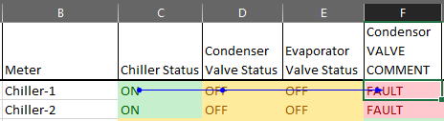

**Precedent Dependent Relation**

**Formula:** **=IF(EXACT(C2,D2),"OK","FAULT")**

* **Evaporator Valve Comment:** Similar to the condenser valve we have to check the evaporator valve in order to match the status of the chiller with the evaporator water inlet valve to prevent either wastage of water or power when either of the parameter is inactive.

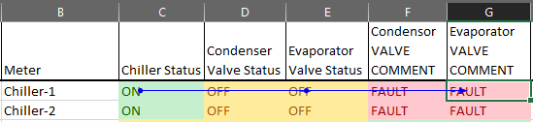

**Precedent Dependent Relation**

**Formula: =IF(EXACT(C2,E2),"OK","FAULT")**

* **Delta:** Delta is simply the temperature difference of the evaporator inlet and outlet.

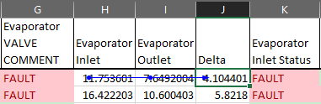

**Precedent Dependent Relation**

**Formula: =(H2-I2)**

* **Evaporator Inlet Status:** The evaporator inlet status field checks whether the inlet temperature for the evaporator is in the desired range or not.

The inlet temperature must be in the range of 12-14 degrees

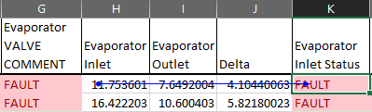

**Precedent Dependent Relation**

**Formula: =IF(AND(OR(H2>12,H2=12),OR(H2<14,H2=14)),"OK","FAULT")**

* **Evaporator Outlet Status:** The evaporator outlet status field checks whether the outlet temperature for the evaporator is in the desired range or not.

The outlet temperature must be in the range of 6-10 degrees

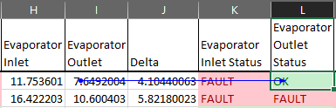

**Precedent Dependent Relation**

**Formula: =IF(AND(OR(I2>6,I2=6),OR(I2<10,I2=10)),"OK","FAULT")**

* **Evaporator Delta Status:** The evaporator delta status check whether the chiller is providing the appropriate drop in temperature or not for the water supplied across it.

Condition: Delta must be between 4-5 degrees.

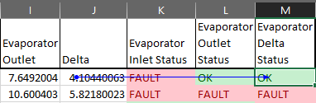

**Precedent Dependent Relation**

**Formula: =IF(AND(OR(J2>4,J2=4),OR(J2<5,J2=5)),"OK","FAULT")**

**Process Flow:**

